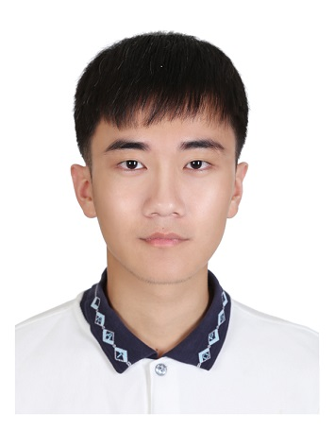Title of Your Presentation
Wei-Long Chen¹, Naoto Kobayashi², and Han-Sheng Chuang¹
(iscebt2018@gmail.com)
¹ Department of Biomedical Engineering
National Cheng Kung University, Tainan 701, Taiwan.
² Department of Chemical Engineering
Tohoku University, Sendai, Japan.

Abstract- This is a template of the abstract for isCEBT2018. Use A4 paper size. The top and left margins should be 20 mm. Use 14-point bold face Times New Roman for the paper’s title, 10.5-point bold face Times New Roman for the authors’ names and your e-mail address, 10-point Times New Roman for the affiliations, and 10-point Times New Roman for the main body and figure captions. The main text part should be fully justified with single spacing. The abstract should be written in English with less than 500 words and 1 figure (table).
Please submit a one-page abstract including figures, tables, and references by June 30, 2018. The abstract should be converted into "PDF" file. Send your PDF file and word file to iscebt2018@gmail.com
Write English abstract here. Write English abstract here. Write English abstract here. Write English abstract here. Write English abstract here. Write English abstract here. Write English abstract here. Write English abstract here. Write English abstract here. Write English abstract here. Write English abstract here. Write English abstract here. Write English abstract here. Write English abstract here. Write English abstract here. Write English abstract here. Write English abstract here. Write English abstract here. Write English abstract here. Write English abstract here. Write English abstract here. Write English abstract here. Write English abstract here. Write English abstract here. Write English abstract here. Write English abstract here. Write English abstract here. Write English abstract here. Write English abstract here. Write English abstract here. Write English abstract here. Write English abstract here. Write English abstract here. Write English abstract here. Write English abstract here. Write English abstract here. Write English abstract here. Write English abstract here. Write English abstract here. Write English abstract here. Write English abstract here. Write English abstract here.
Write English abstract here. Write English abstract here. Write English abstract here. Write English abstract here. Write English abstract here. Write English abstract here. Write English abstract here. Write English abstract here. Write English abstract here. Write English abstract here. Write English abstract here. Write English abstract here. Write English abstract here. Write English abstract here. Write English abstract here. Write English abstract here. Write English abstract here. Write English abstract here. Write English abstract here. Write English abstract here. Write English abstract here. Write English abstract here. Write English abstract here. Write English abstract here. Write English abstract here. Write English abstract here. Write English abstract here. Write English abstract here. Write English abstract here. Write English abstract here. Write English abstract here. Write English abstract here. Write English abstract here. Write English abstract here. Write English abstract here. Write English abstract here. Write English abstract here. Write English abstract here. Write English abstract here. Write English abstract here. Write English abstract here. Write English abstract here. Write English abstract here. Write English abstract here. Write English abstract here. Write English abstract here. Write English abstract here. Write English abstract here. Write English abstract here. Write English abstract here. Write English abstract here. Write English abstract here. Write English abstract here.
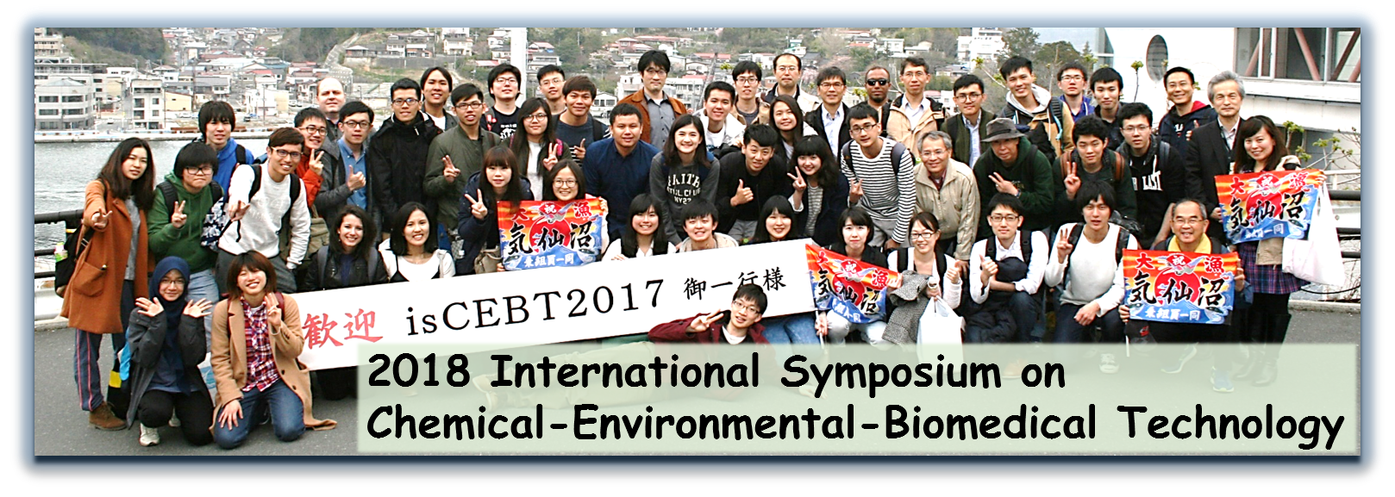
Fig 1. Figure captions：Times New Roman10 points

References
1) W. J. Kuo, Y. S. Sie, and H. S. Chuang, Biomicrofluidics, Vol.8, pp. 024116, 2014.
2) T. Hirotsu, H. Sonoda, T. Uozumi, Y. Shinden, K. Mimori, Y. Maehara, N. Ueda, M. Hamakawa, PLoS One, Vol. 10, pp. e0118699, 2015.

